SIMATS ENGINEERING (SAVEETHA SCHOOL OF ENGINEERING)
Department of Computer Science and Engineering
CO2 ASSESSMENT TOOL 1 – Scenario-Based Requirement Analysis
Course Code: | CSA10 / CSA1063 | Course Title: | Software Engineering
CO Assessed: | CO2 | Assessment: | Assessment Tool 1 – Scenario-Based Requirement Analysis
Weightage: | 20% | Total Marks: | 25
CO2 Statement: | Perform detailed requirements analysis, design scalable architectures, and prioritize features with a focus on cross-disciplinary skills
Student Name: | S. Abisheka Priyen | Reg. No.: | 1911260304
Date: | 23/10/2026 | Duration: | 60 minutes

Code of Conduct
I, S. Abisheka Priyen (1911260304), certify that this submission is my original work and that I have adhered to the guidelines specified for this assessment. I understand that any violation of academic integrity rules will result in disciplinary action.
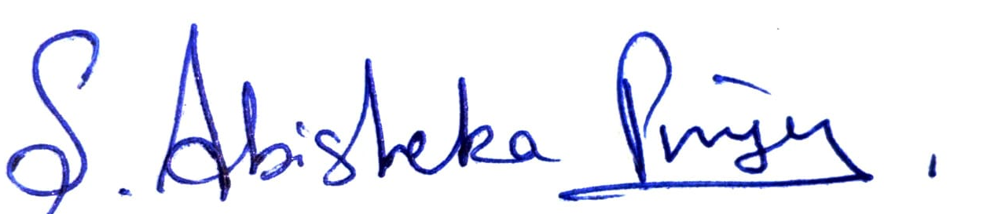
Signature of the Student:
Annexure A – Scenario-Based Requirement Analysis
Instructions to Students:
Each student will be assigned an individual software project problem statement. Analyze the given scenario and prepare a complete Software Requirement Analysis document by following the steps below.
Question
Based on the assigned problem statement, perform a Scenario-Based Requirement Analysis and prepare a Software Requirement Specification (SRS) document. Your analysis should include the following:
1. Study and Analyze the Scenario: Understand the problem, business domain, stakeholders, challenges and objectives.
2. Identify Functional and Non-Functional Requirements: List functional requirements and performance, security, reliability, usability, scalability, maintainability and availability.
3. Identify Actors and Use Cases: List primary and secondary actors, their use cases, and provide a UML use case diagram.
4. Prepare the Software Requirement Specification (SRS): Include introduction, problem description, scope, functional and non-functional requirements, use cases, data, interfaces and features.
5. Identify Assumptions and Constraints: List assumptions and technical, operational, economic, legal and time constraints.
6. Validate Requirement Completeness and Consistency: Check completeness, ambiguity, redundancy and conflicts, and suggest improvements.

Topic 32 – Real-Time Digital Twin for Industrial Equipment Predictive Maintenance

1. Study and Analyze the Scenario

1.1 Business Domain and Problem Description
The project belongs to industrial automation and predictive maintenance. Factories use motors, pumps, compressors and other machines whose unexpected failures interrupt production and increase maintenance expenses. Sensors provide live readings such as temperature, vibration, pressure and speed, but these values are often viewed separately from historical service records. The proposed system creates a real-time digital twin, or virtual representation, of each machine. It processes incoming readings, identifies abnormal operating conditions, estimates maintenance risk and supports repair planning.

1.2 Stakeholders and Objectives
Machine operators require an understandable live equipment view. Maintenance technicians need alerts and work orders. Reliability engineers need trends, failure-risk information and service history. Plant managers need uptime and maintenance summaries. Data scientists maintain prediction models, while administrators and DevOps engineers manage security, integrations and availability. The objectives are to collect telemetry, maintain current equipment state, detect anomalies, generate predictive alerts, retain maintenance records and support essential local monitoring during communication outages.
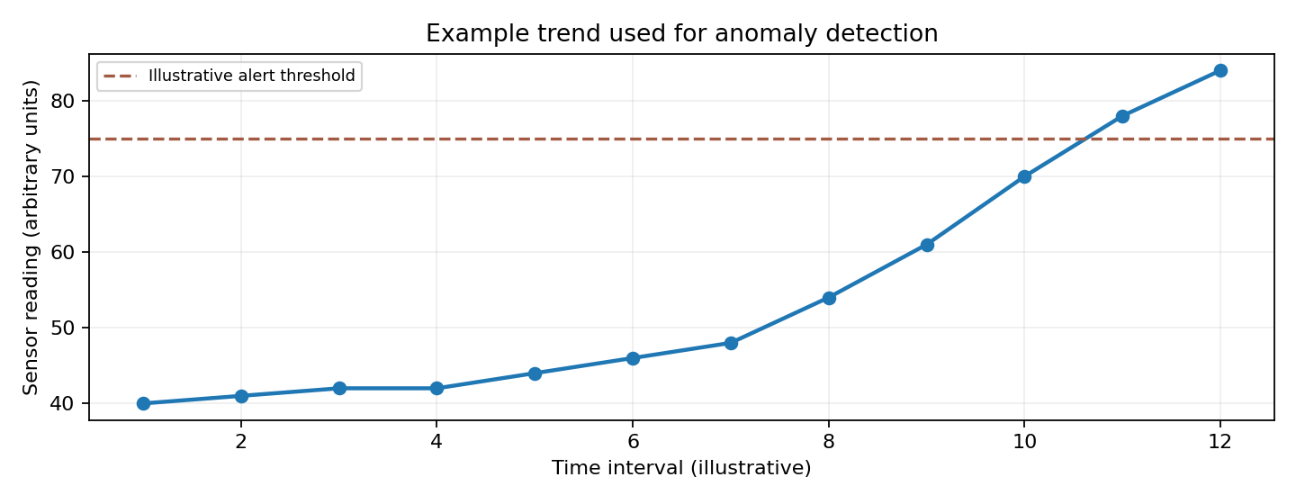
Figure 1. Illustrative sensor trend only; not actual industrial measurements.

1.3 Existing Challenges
Traditional reactive maintenance detects failures too late, while fixed-interval servicing may replace healthy components unnecessarily. Additional challenges include noisy or missing sensor data, different industrial protocols, large event volumes, false alarms, incomplete maintenance history, cybersecurity risks and temporary network interruptions. The software must connect live observations with historical evidence and present clear, actionable results.

2. Functional and Non-Functional Requirements

2.1 Functional Requirements
ID | Requirement | Description
FR01 | Equipment registration | Administrators can register machines, sensors and their associations.
FR02 | Telemetry ingestion | The platform accepts timestamped sensor readings and rejects invalid events.
FR03 | Digital twin state | The platform updates each machine’s latest condition and health status.
FR04 | Dashboard | Operators view machine status, sensor trends and last-update time.
FR05 | Anomaly detection | Configured rules identify abnormal readings and create anomaly events.
FR06 | Predictive analytics | The platform calculates maintenance risk using telemetry and historical records.
FR07 | Alerts | The platform creates, prioritizes and tracks equipment alerts.
FR08 | Maintenance work orders | Technicians create, assign, update and close maintenance tasks.
FR09 | Maintenance history | Authorized users retrieve repairs, inspections and linked telemetry.
FR10 | Offline monitoring | The edge gateway continues essential local rules during network outages.
FR11 | Re-synchronization | Buffered readings are transmitted without duplicates after reconnection.
FR12 | User access and APIs | Authenticated users access only permitted features through secured interfaces.

2.2 Non-Functional Requirements
Performance: The proposed design targets near-real-time updates for normal connectivity; precise latency targets must be confirmed with plant stakeholders. Reliability and availability: durable event queues, retries, health checks and local edge rules reduce service interruption. Scalability: ingestion and processing services can be deployed as independently scalable containers. Security: encrypted communication, role-based permissions, audit logs and secure credential management protect operational data. Usability: dashboards show severity, timestamps and clear machine status. Maintainability: modular APIs, automated tests, CI/CD and documented interfaces simplify changes. Data integrity: equipment IDs, event IDs, timestamps and validation help avoid misattribution and duplicate records.

3. Actors and Use Cases

3.1 Primary and Secondary Actors
Primary actors are the machine operator, maintenance technician, reliability engineer and plant manager. Supporting actors are the system administrator, sensor/edge gateway, predictive analytics service and notification service. The gateway supplies data automatically, while the analytics and notification services support system workflows.
Actor | Main use cases
Machine operator | View equipment health; inspect sensor readings; acknowledge operational warning.
Maintenance technician | View alerts; create and update work orders; record completed maintenance.
Reliability engineer | Review anomalies; analyze trends; inspect predictions and maintenance history.
Plant manager | Review equipment summaries and maintenance priorities.
System administrator | Register machines and sensors; manage user access.
Sensor / edge gateway | Submit readings; perform offline local checks; synchronize buffered data.
Analytics / notification services | Calculate risk; generate and deliver alerts.

3.2 UML Use Case Diagram
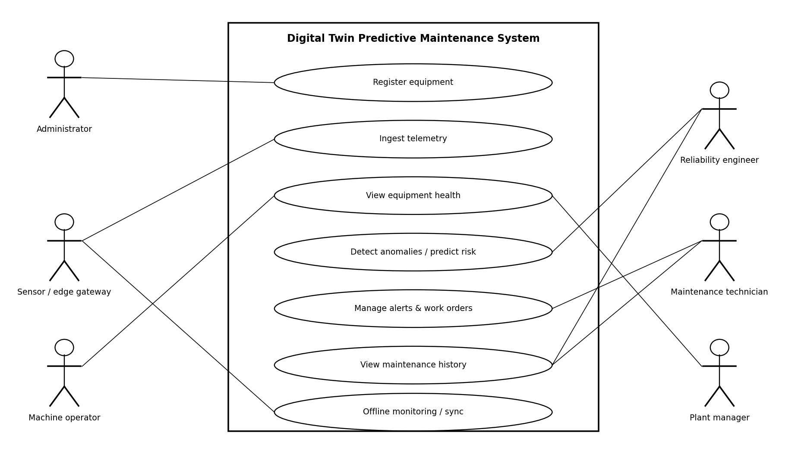
Figure 1. Proposed UML use case model. The diagram shows major user and gateway interactions with the platform.

4. Software Requirements Specification (SRS)

4.1 Introduction and Purpose
This Software Requirements Specification defines the proposed digital twin platform for industrial equipment predictive maintenance. It provides a shared basis for development, testing and stakeholder review. The specification describes expected software behaviour rather than claiming the system has already been implemented.

4.2 Scope of the System
The system covers equipment registration, sensor ingestion, real-time twin state, anomaly detection, maintenance risk analysis, alert management, historical maintenance records, dashboards, secure APIs and resilient edge monitoring. Physical machine repairs, sensor manufacture and direct control of safety-critical machinery are outside the proposed software scope.

4.3 Functional and Non-Functional Specifications
The system shall implement FR01–FR12 described in Section 2. Functional workflows shall be verified through registration, ingestion, dashboard, anomaly, alert, maintenance and offline-recovery test cases. Non-functional acceptance targets, such as maximum processing delay, supported sensor volume and recovery time, must be agreed with the industrial stakeholders before final acceptance.

4.4 Use Case Descriptions
Use case | Precondition | Main flow / result
UC01 View equipment health | Equipment registered; valid readings available | Operator selects machine; system displays latest state, trends and timestamp.
UC02 Predict maintenance risk | Telemetry and configured model/rules available | System evaluates readings; creates a risk event when configured criteria are met.
UC03 Manage maintenance | Technician authenticated; alert exists | Technician creates work order, assigns status and records completed action.
UC04 Offline synchronization | Gateway has buffered events; connection restored | Gateway resends events; server deduplicates by event ID and confirms receipt.

4.5 Data Requirements
Equipment records require equipment ID, type, location and status. Sensor records require sensor ID, associated equipment ID, measurement type and unit. Telemetry events require unique event ID, timestamp, value, quality indicator and sensor ID. Twin-state records maintain latest readings, health state and update time. Alerts contain severity, reason, equipment reference, timestamp and status. Maintenance records contain work-order ID, assigned technician, action, dates, notes and resolution. Retention periods and personal-data policies must be defined by the organization.

4.6 External Interface Requirements
Sensors or gateways send data through authenticated ingestion interfaces, potentially using MQTT or HTTPS depending on plant equipment. Secure REST APIs provide equipment, alerts, work orders and reporting functions to the dashboard and authorized integrations. The interface must display stale-data indicators during outages and clearly distinguish measured values from predicted risk. Notifications may use organization-approved channels, and all service connections should use encrypted transport.
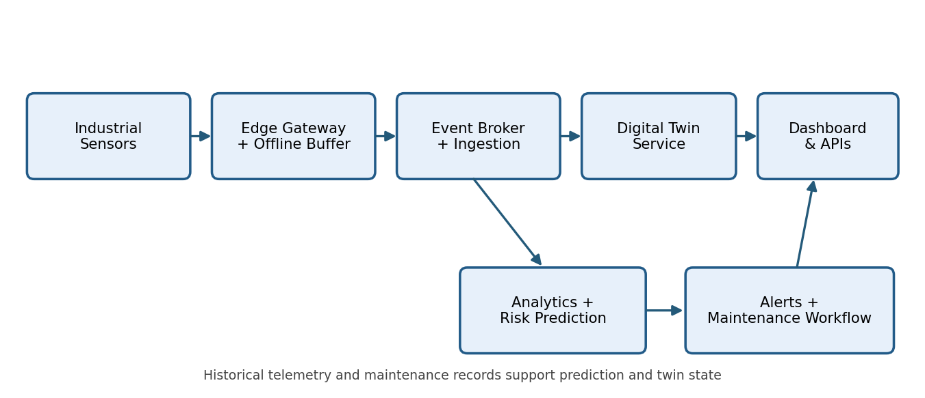
Figure 2. Proposed system architecture and event-processing flow.

4.7 System Features and Architecture
The architecture consists of industrial sensors, an edge gateway, an event-ingestion service, an event broker, digital twin state management, time-series and maintenance databases, anomaly/prediction services, alert and workflow services, and secure dashboard APIs. Telemetry travels from equipment through the edge gateway to ingestion and event processing. Valid events update twin state and historical storage. Analytics reads telemetry and maintenance history to identify risk; resulting alerts reach technicians and create work orders. During an outage, the gateway performs essential local checks and buffers readings until reconnection. Containerized services, CI/CD, logging and metrics support deployment and operational monitoring.

5. Assumptions and Constraints

5.1 Assumptions
The plant supplies functioning sensors with known units and identifiable machines. The gateway has sufficient local storage for a limited outage. Stakeholders provide maintenance history and agree on abnormality thresholds. Authorized technicians review predictive alerts before taking maintenance action. Reliable timestamps and a network connection are available under normal operation.

5.2 Constraints
Technical constraints include sensor compatibility, network bandwidth, edge processing capacity, storage growth and incomplete training data. Operational constraints include maintenance windows, staff availability and the need to avoid disrupting production. Economic constraints include gateway hardware, cloud or server costs and integration expenses. Legal and policy constraints include industrial cybersecurity rules, access control, audit retention and applicable data protection obligations. Time constraints require prioritizing core ingestion and visibility before advanced predictions. This software is advisory and does not replace certified machine safety controls.

6. Validate Requirement Completeness and Consistency

6.1 Validation Approach
Review requirements with operators, maintenance staff, reliability engineers, administrators and managers. Trace each business objective to at least one requirement and acceptance test. Verify that each requirement has a clear actor, input, expected outcome and failure behaviour. Test representative cases using simulated sensor streams, invalid payloads, repeated event IDs, stale readings, abnormal conditions, restricted access and network interruption.

6.2 Ambiguities, Conflicts and Improvements
Terms such as “real-time”, “predictive” and “high availability” are not measurable until targets are agreed. The system should define telemetry update intervals, acceptable alert latency, supported machine count, alert precision, outage buffering duration and recovery objectives. Requirements for offline monitoring and centralized dashboards are not contradictory if the dashboard clearly indicates stale cloud data. Alert severity, escalation rules and model retraining responsibilities should be approved by stakeholders. Duplicate descriptions of telemetry collection and storage should be cross-referenced rather than repeated as separate requirements.

6.3 Requirement Traceability and Completion Check
Objective | Requirements | Verification
Collect live telemetry | FR01, FR02 | Register a sensor; ingest a timestamped event.
Show equipment health | FR03, FR04 | Compare dashboard state with most recent accepted event.
Detect and predict problems | FR05, FR06, FR07 | Simulate anomaly and verify corresponding alert.
Support maintenance | FR08, FR09 | Create work order and retrieve history.
Operate during outage | FR10, FR11 | Disconnect gateway; confirm local alert and eventual sync.
Secure and maintain platform | FR12 and quality requirements | Verify permissions, logs, tests and health checks.
The proposed specification addresses the stated objectives at a design level. Final completeness requires stakeholder sign-off and measurable acceptance targets for performance, predictive quality, availability and offline recovery.

Rubrics for Calculation
Faculty assessment rubric – CO2 Assessment Tool 1 (25 marks).
Criteria | Excellent (4 Marks) | Good (3 Marks) | Satisfactory (2 Marks) | Needs Improvement (1 Mark)
Scenario Understanding and Problem Analysis (30%) | Demonstrates thorough understanding of the scenario, stakeholders, objectives, and business context with clear analysis. | Demonstrates good understanding with minor omissions. | Basic understanding with limited analysis. | Poor understanding; major aspects missing or incorrect.
Functional and Non-Functional Requirement Identification (25%) | Clearly identifies comprehensive, accurate, and well-classified functional and non-functional requirements. | Identifies most requirements with minor classification errors. | Identifies only basic requirements; several omissions. | Requirements are incomplete, inaccurate, or poorly classified.
Actor Identification and Use Case Modelling (20%) | Correctly identifies all relevant actors and use cases; use case diagram is complete, accurate, and follows UML standards. | Most actors and use cases identified; diagram has minor errors. | Limited actors/use cases identified; diagram partially correct. | Actors/use cases missing or incorrect; diagram absent or inaccurate.
Software Requirement Specification (SRS) Documentation (15%) | SRS is well-structured, complete, professionally organized, and includes all required sections. | SRS is organized with minor missing sections or formatting issues. | SRS includes only essential sections with limited detail. | SRS is incomplete, poorly organized, or lacks essential components.
Assumptions, Constraints, and Requirement Validation (10%) | Clearly identifies realistic assumptions and constraints; validates requirements for completeness, consistency, and ambiguity with appropriate justification. | Identifies most assumptions and constraints; validation is adequate. | Limited assumptions/constraints; validation is superficial. | Assumptions, constraints, and validation are missing or incorrect.

Criteria | Mark
Scenario Understanding and Problem Analysis (30%) | /5
Functional and Non-Functional Requirement Identification (25%) | /5
Actor Identification and Use Case Modelling (20%) | /5
Software Requirement Specification (SRS) Documentation (15%) | /5
Assumptions, Constraints, and Requirement Validation (10%) | /5
TOTAL | /25

